CUES Executive Compensation Survey
Frequently Asked Questions
Reporting

How do I access the survey reports?
Go to the Executive Compensation Survey - cues.org/ecs or Employee Salary Survey – cues.org/ess or through the Products and Services page on cues.org
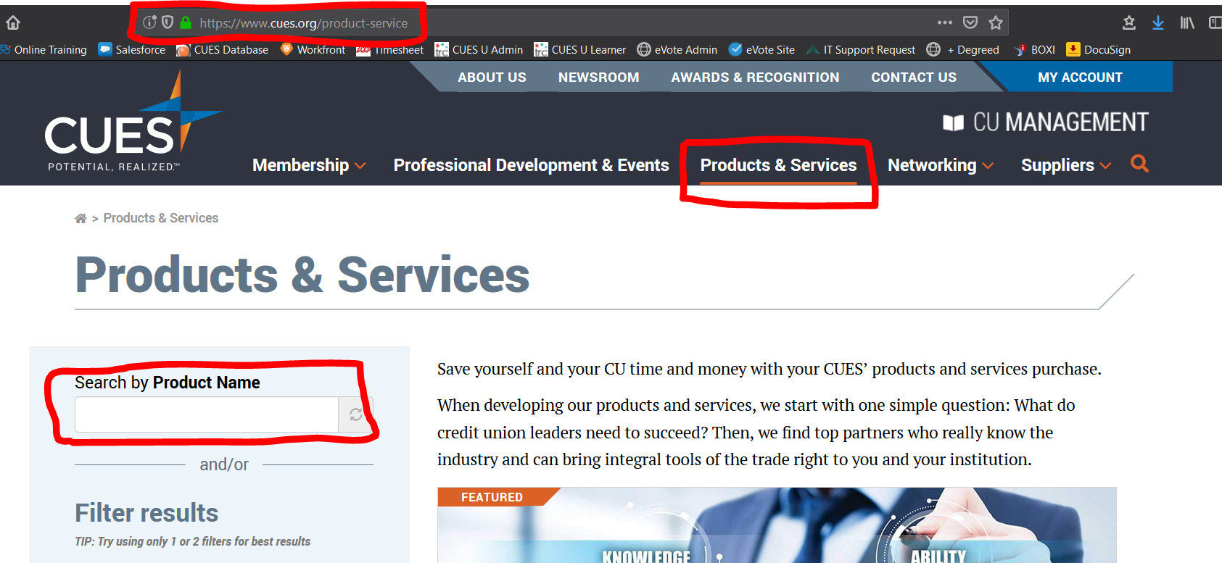
Click the blue RUN REPORTS ribbon in the shaded area on the left. Log in. The page will refresh. Click RUN REPORTS again. The survey portal will open.

What happens if I forget my password?
If you forget your password you can enter your email or username at the “forgot your password” link when logging in or contact Survey Support at 866.508.0744 or surveysupport@cues.org

Can I share my user name and password with others at my credit union that may need access to the
online reports?
Please do not share your login information with anyone. If someone else at your credit union requires access, please contact Survey Support at 866.508.0744 or surveysupport@cues.org

How do I know what criteria and parameters to choose when creating a report?
Choose criteria based on your credit union’s Compensation Philosophy. If your credit union does not have a Compensation Philosophy, use our Compensation Philosophy Toolkit to get started.

How can I print my information?
Because printer settings may differ by browser type, we recommend printing your report after exporting to Excel or PDF. If you choose to print from your browser, you can do so by using the File > Print option on your browser toolbar or by using the print button on the top toolbar.

When trying to create an online report, I keep getting zero respondents. What am I doing wrong?
It is possible that you are using too many filters to create your report and/or your parameters are too narrow. Consider using less criterion and broader ranges. For example, using every available criterion in your selection will most likely not produce any results. Choose variables that represent how your credit union determines its pay.

Why is the “Bonus” figure shown two different ways?
The bonus metric is shown in two separate ways. “Bonus (bonus eligible only)” only includes those respondents who indicated that they are eligible for a bonus. The sample size for the bonus amount in this instance may not match the sample size for the base salary measure. “Bonus (all respondents)” imputes zeroes into the bonus value for those who indicated that they were not bonus eligible. By not including zeroes, bonuses may be overstated for the “typical” employee. By including zeroes, the bonus figures may be understated for those who are bonus eligible. By showing it each way, users will be able to choose which metric works best for their organization.

Why is the “Other Taxable Compensation” figure shown two different ways?
Similar to the description above on bonuses, the “Other Taxable Compensation (other eligible only)” includes only those respondents who provided a value for that metric on the survey form. “Other Taxable Compensation (all respondents)” imputes a zero for this measure if a value was not given.

How do I read the report?
- Selected Filters: You will see the filters you selected for your report. For example, the below information shows credit unions with up to $75 million in assets for 2019.
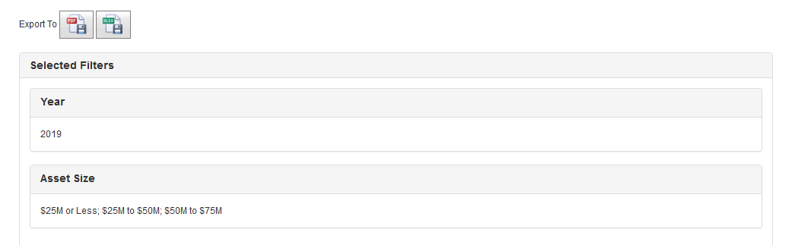
- Your Credit Union’s Data: Your CU information will be populated if you participated in the survey in the year you have selected.
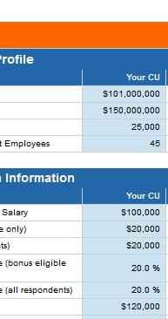
- Credit Union Profile: The Credit Union Profile section shows the asset size, loan portfolio size, member base and full-time equivalent employees for the credit unions included in each data point (average, 10%, 25%, Median, 75%, 90%)
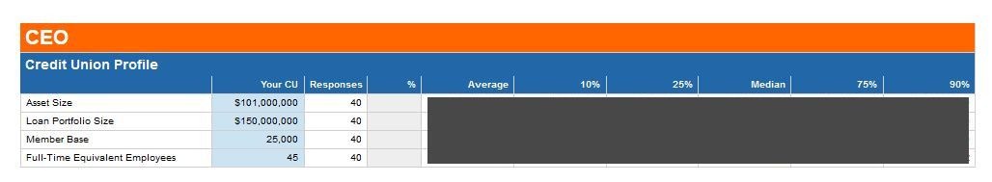
- Use the profile information as a way to find the percentile that is the closest match for your credit union. You can then follow that column down to see compensation and benefits information for that group. Keep in mind: All credit unions do not fill out the survey each year. From year to year, you may need to change the filters you use and/or the percentile you compare to each year in order to get a sample that is close to your credit union’s profile.
- Compensation Information: Once you have determined which percentile most closely fits your credit union, you can continue to look at that percentile in the compensation information and other areas of the report.
